v.1 Obstetric Anaesthetists’ Association 2024. Issued under Creative Commons license CC BY-NC-SA 4.0. See www.oaa-anaes.ac.uk/qrh

QRH instructions for use
The QRH is intended for use by individuals who are familiar with it and who are practised in its use.
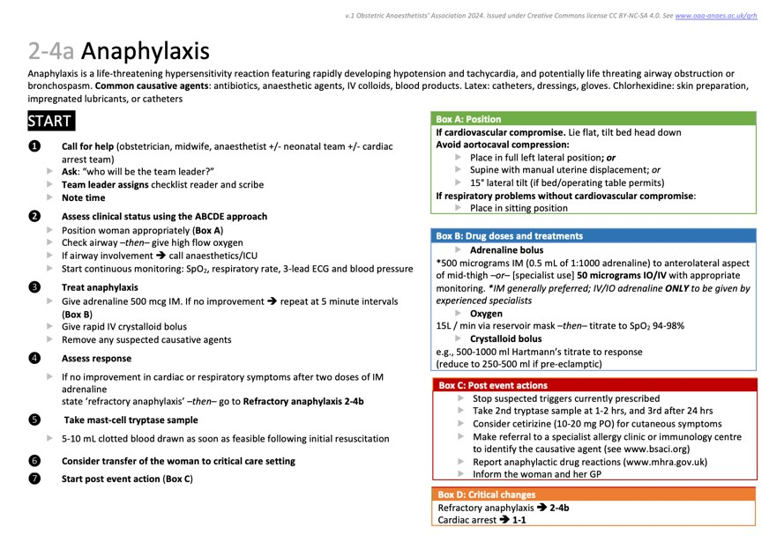
Each action card guidance follows the same format:
❶

❷

❸

❹

❺

1. Guidance number, name and version number.
2. A brief description of the clinical situation for which the guidance is written.
3. The body of the guidance.
4. Call out boxes, which may be referred to in the body text.
 Blue = drug doses
 Green = CPR information
 Black = equipment instructions
 Purple = other reference information
 Red = post-resuscitation / birth care
 Orange = *critical changes *Critical changes are not referred to in the body of the text
5. Guidance may suggest changing to one of the other action cards, like this: → 2-1.
6. The guidance number is repeated for easy finding without the need for a tabbed folder.
Each guidance should be used in the same simple way:
 Start at START.
 Work through the numbered bullet points in order.
 Where indicated, refer to the call out boxes on the right.
 Where indicated, move to another action card.

We recommend:
 Having a copy available in all clinical areas where pregnant women are cared for.
 One person should read the guidance aloud; they should NOT be the person performing the actions.
 The reader should ensure that the guidance is followed systematically, thoroughly and completely and that steps are not omitted.
 Whenever experienced help arrives, consider delegating leadership to them; they have a fresh pair of eyes and may be able to make a more clear-headed assessment.

